Press Release | May, 2019

iManufacturing 2019
Shanghai New International Expo Centre
Shanghai, China, 25-27 November, 2019

We Not Only Focus on Intelligent Manufacturing
We Also Provide Solutions

Benefit from clear positioning, 40% of the booth have been reserved
Asia’s Leading Exhibition for Intelligent Manufacturing & Integrated Solutions (abbreviation: iManufacturing) has been clearly positioned since its launch and is unique among various other intelligent manufacturing exhibitions. With in-depth communication with companies and industry experts, iManufacturing is gradually developing; and the positioning and concept of the exhibition has gained more and more attention and recognition. The organizers have discussed the details of the exhibition with numerous well-known companies within the industry, including Huawei, Lenovo, ABB, Siemens, Bosch, SAP, IBM, GF, ThyssenKrupp, Dell China, Balluff, Omron, ESA Automation, Norgren, Topstar Robots, Midea, HIK VISION, KUKA, Pilz, Cognex, TURCK, WAGO, Festo, Leuze, Beckhoff Automation, UNICLOUD, SCHUNK, IFM, Weidmüller and many more. As of the end of April, 40% of the exhibition area has already been booked.
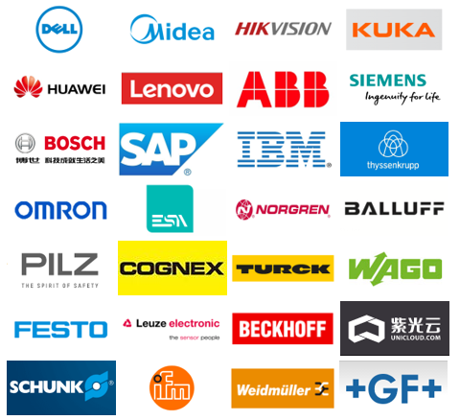
(Part of potential exhibitors)

As an exhibition and conference integrated platform that truly focuses on high-end intelligent manufacturing in China and the Asian region, iManufacturing aims to provide forward-looking industrial 4.0 solutions for the Chinese manufacturing industry. Here you will be able to:
Stand at the Center of Intelligent Manufacturing – experience cutting-edge products and technology brought by the top 200+ companies
Meet Top Level Experts and Business Cases - listen to the tips and best practices shared by 40 industry-leading experts
Make Business Connections and Generate Sales Leads - sell products, talk about projects or find partners from amongst more than 10,000 decision makers
Experience the Future of Manufacturing - watch world leading intelligent production system demonstrations and integration solutions

Visitors pre-registrations are hot on line, business matching is imperative
The visitor pre-registration system of iManufacturing was officially opened on the official website www.asia-iman.com in early March. In two-month time it has already received a large number of pre-registrations, exceeding the expectations of the organizers. Among the pre-registered visitors, there are decision makers from well-known brands including JD, Sany Group, Yuwell, Shanghai Yangshan Port, Michelin Tire, Roche Diagnostics, Highset, All-link, Samsung Investment, Jiusheng Electric, Zeyi IOT Technology, Demark Holdings, Horauf, Jielong Industrial, Philips, 3M China, Baidu, Founder, Haier Group, Mitsubishi Electric, Changhong Electric, Suning Holdings, etc.
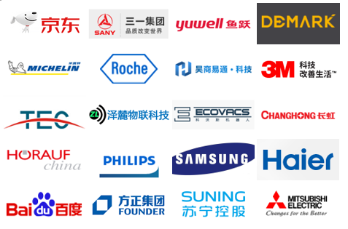
(Part of pre-registered visitors)

In order to provide better trade services for exhibitors and visitors, a business matching service will be launched soon. The organizers will provide a vibrant business matching platform and an accurate matching service for both suppliers and buyers, to optimize the business results of participants and visitors.

Strong alliance, co-organized by CCIA
The China Communications Industry Association Committee for Integration of Informatization and Industrialization (hereinafter referred to as the “CCIA”) is a secondary association established by the China Communications Industry Association in 2014. Under the leadership of the Association, it is committed to promoting the integration of many new age technologies - like the latest internet technologies, information and communication technology, materials technology and artificial intelligence technology with the real economy; thus supporting the deep integration of new technology and the real economy, enabling them to come up with better technologies, new industries, new industry formats, and new business models. They are also committed to research and promotion of the transformation of old and new kinetic energy; contribution to a more powerful network, and more powerful manufacturing sector; to make the country stronger; and to serve the digital and real economy, society and enterprises.

Since 2016, the CCIA has continued to carry out the Intelligent Manufacturing Promotion Series Activities. During 2016-2018, more than 40 offline events were successfully held, covering over 20 cities including Jinan, Xi'an, Shenzhen, Nanjing, Chongqing, Tai'an, Dalian, Beijing, Qingdao, Shanghai, Guangzhou, Hangzhou, Luzhou, Foshan, Weihai, Nantong, Ningbo, Yantai, Zhengzhou and Wuhan. Nearly 10,000 service providers and manufacturing enterprises participated in this event. In the past three years, more than 520 projects with a total project value of 686 million yuan, have successfully been initiated through the Intelligent Manufacturing Promotion Series Activities. Now the CCIA has officially become the co-organizer of iManufacturing. This strong alliance with the organizers will definitely bring valuable activities and higher quality content to the exhibition.

Phenomenal collocated events, helping you to open the door to intelligent upgrades
In addition to the exhibition's main forum, the ‘International Intelligent Manufacturing Forum’, the organizers will concurrently carry out sub-forums of five major sectors, including Smart Packaging, Aerospace, Automotive, Gear and Integration of Informatization and Industrialization. Participants will be able to get an overview of the industry's current status and prospects and have in-depth discussions of the various segments of intelligent integration and manufacturing.

The main topics include: ‘The Development Trend of Intelligent Integrated & Intelligent Factory’, ‘Deeply Analysis of German and China Industrial 4.0’, ‘Innovation Idea and Strategy of Intelligent Manufacturing’, ‘Case Study of The Application of Networked Collaborative Manufacturing’, ‘Technology and Business Model Innovation Based on The Internet’, ‘Improve Intelligent Manufacturing Combining Enterprises Situation’. Meanwhile, honored guests from various organizations including ‘Ministry of Industry and Information Technology’, ‘China Machinery Industry Federation’, ‘China Machinery Industry Federation Intelligent Manufacturing Branch’, ‘China Artificial Intelligence Society’, ‘China Machinery Science Research Institute Automation Institute’, ‘Shanghai Automobile Group Co., Ltd.’, ‘China Commercial Aircraft Co., Ltd.’, ‘Norinco Group’, ‘China Aerospace Association’, ‘Alibaba Cloud-Automotive and Intelligent Travel Division’, ‘German Machine Tool Association’, ‘Chinese Academy of Engineering’, ‘Chinese Society of Aeronautics and Astronautics’, ‘AVIC China Aero-polytechnology Establishment’, ‘SAE International‘, ‘Beihang University’, ‘China Aerospace Science and Technology Corporation’, ‘China CRRC Co., Ltd.’, ‘China FAW Group Co., Ltd.’ and ‘Shenyang SIASUN Robot & Automation Co., Ltd.’ will gather in Shanghai to define the development trend and map the blueprint of the global intelligent manufacturing field for the participants; talk about cutting-edge technologies in the industry; and give practical advice to enterprises who want to transform and upgrade their businesses.
Please view www.asia-iMan.com to get more information about the event.

Co-located with Shanghai World of Packaging (swop)
swop is the essential event for the food, beverage, confectionery, baked goods, pharmaceuticals, cosmetics & daily care products, non-food consumer goods and industrial goods sectors. swop is the comprehensive platform not only meeting current demands for the entire supply chain but also identifying packaging trends for the future. See details at: www.swop-online.com.

- END -

Media Contact:
Ms. Tracy Cui
Messe Düsseldorf (Shanghai) Co., Ltd.
Tel: +86-21-61698342
Fax:+86-21-61698301
Email: tracy.cui@mds.cn

Messe Düsseldorf (Shanghai) Co., Ltd. (MDS)
Messe Düsseldorf China Ltd., the subsidiary of Messe Düsseldorf GmbH, which is one of the world's top 5 exhibition organizers, is committed to introducing world's no. 1 trade fairs to China relying on its complete and mature marketing & service network in China. To provide better individualized solutions for Chinese market and promote localization services and operation strategies, Messe Düsseldorf China Ltd. established Messe Düsseldorf (Shanghai) Co., Ltd, its wholly foreign investment subsidiary after entering China for ten years. Messe Düsseldorf (Shanghai) Co., Ltd is committed to enlarge exhibition business scope and develop diversified cooperation relationships, as well as enhancing the influence of exhibition propeling the industry and the industry developing the economy, while is also contributing to the reform and opening up of China. Messe Düsseldorf GmbH is the organizer of drupa, the No.1 largest printing exhibition all over the world. More information: www.mds.cn.

China National Machinery Industry International Co., Ltd.
China National Machinery Industry International Co., Ltd. (SINOMACHINT) is a holding subsidiary of China National Machinery Industry Corporation (SINOMACH), a large state-owned business conglomerate and a Fortune Global 500 company. With the overall strategy of commercial exhibition and international trade as its “two engines” , SINOMACHINT is committed to building an integrated service platform for technology exchange and trade promotion between Chinese and foreign enterprises.
SINOMACHINT has over 20 investment enterprises. In recent years, it has been granted honors including “Top 10 Most Influential Exhibition Companies in China”, “Top 10 Exhibition Engineering Service Brands in China” as well as the “Best Exhibitor of China.” Today’ s SINOMACHINT, as a central enterprise, has already progressed into the largest and most comprehensive Chinese exhibition giant. Commercial exhibition is the core business of SINOMACHINT with over 60 years of experience in exhibition organizing and a professional organization team. SINOMACHINT has established a complete exhibition business system that integrates independent organization of domestic and international exhibitions, agency service for overseas exhibitions and exhibition engineering.

